SEPTEMBER 24th 2022 0800-1530 EST COME OUT AND CELEBRATE THE LAUNCH DATE FOR THE
USS MASSACHUSETTS BB 59
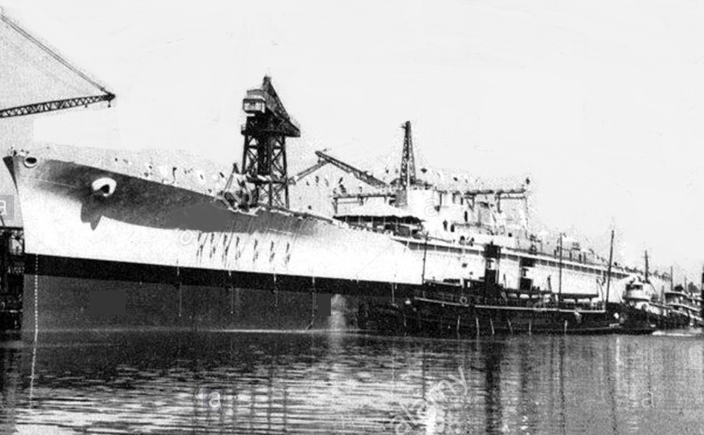
Launched September 23, 1941 at the Bethlehem Steel Corp. Fore River Shipyard in Quincy, MA
Contact Rick KB1TEE kb1tee@gmail.com

